**How to Disconnect Instagram and Facebook accounts**

# **A) Disconnect Accounts using the Facebook Website:**

**Step 1**: Click on the ‘Settings’ on the left side of the profile page.

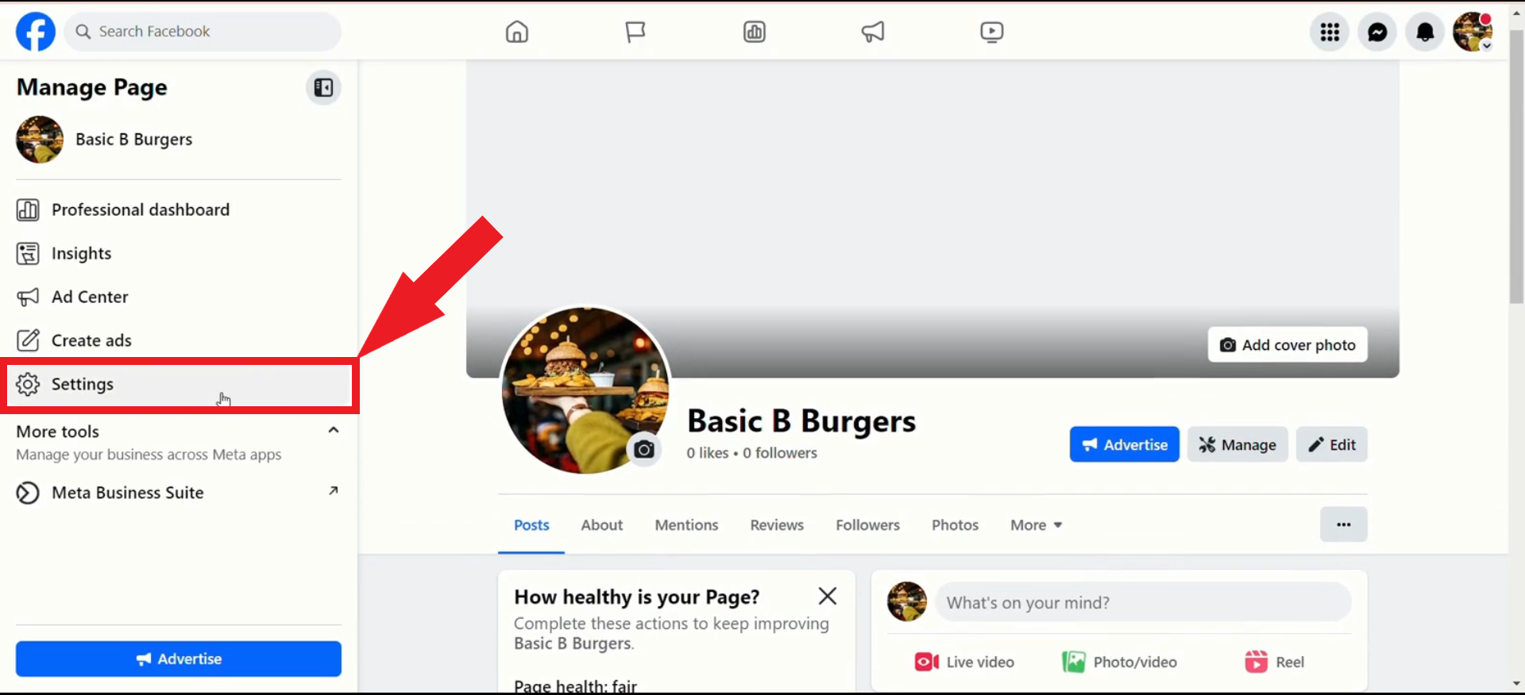

**Step 2**: Click 'Linked Accounts' on the left side.

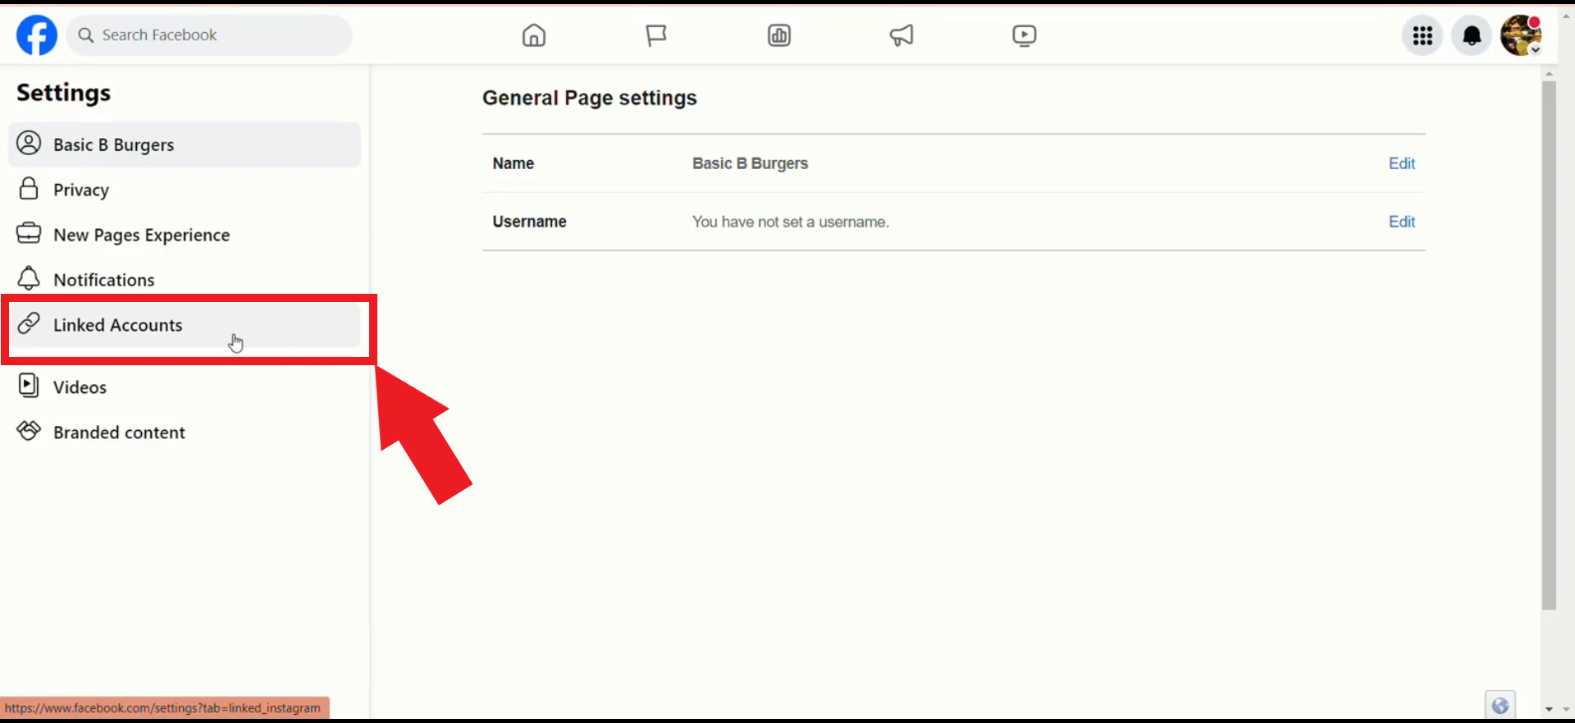

**Step 3**: Click on 'Disconnect account'.

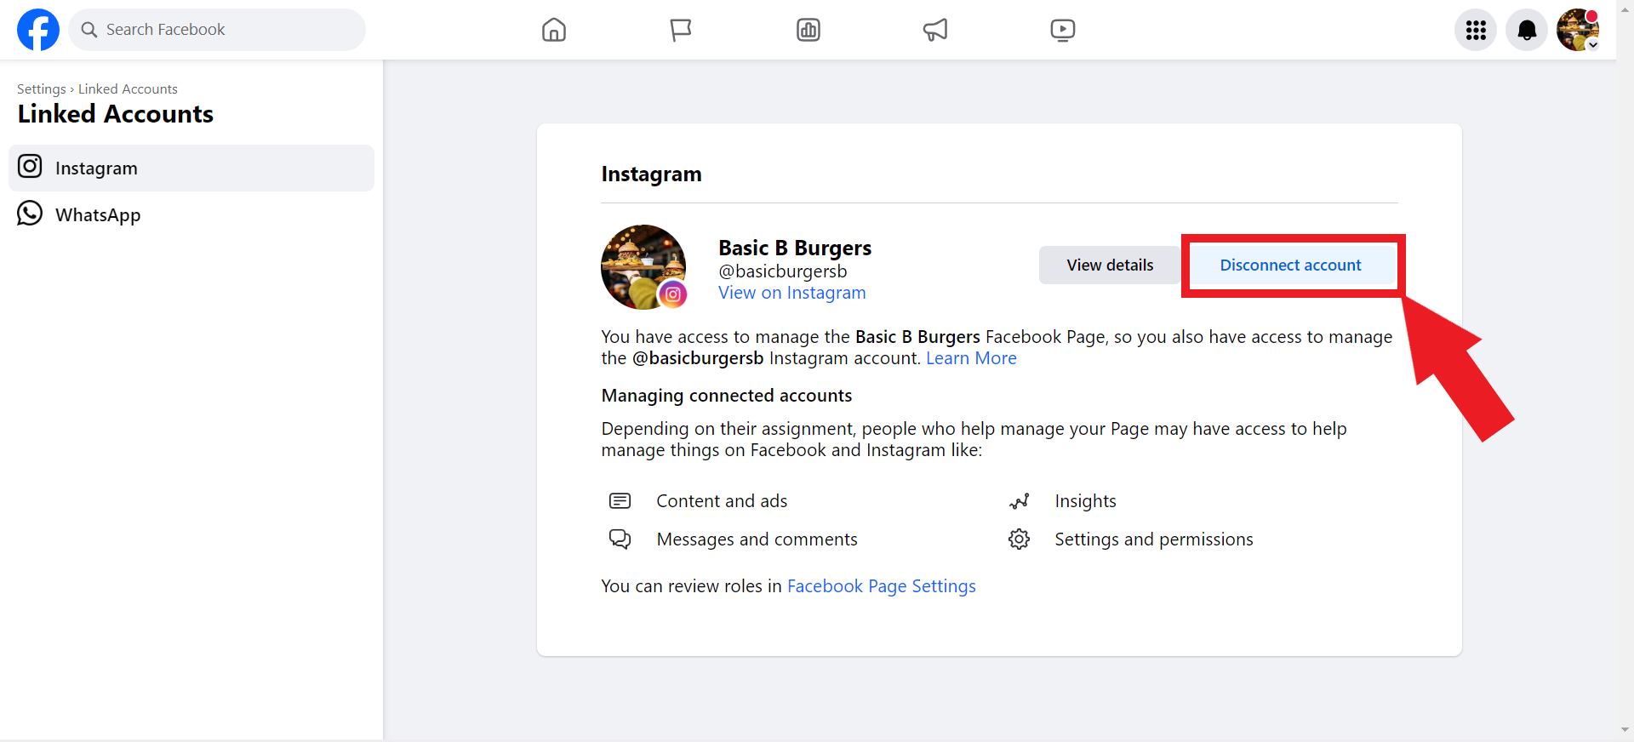

# **B) Disconnect Accounts using the Instagram App:**

**Step 1**: Select ‘Edit Profile’.

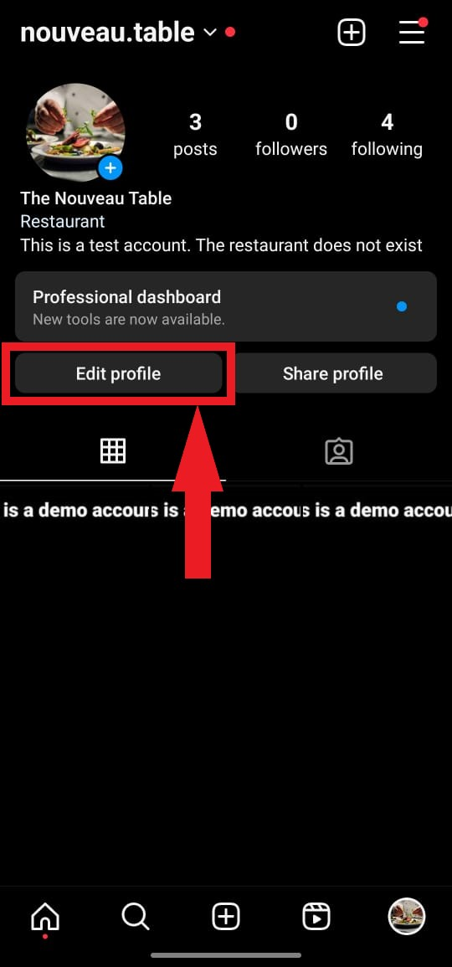

**Step 2**: Select ‘Page’ to disconnect the Facebook page.

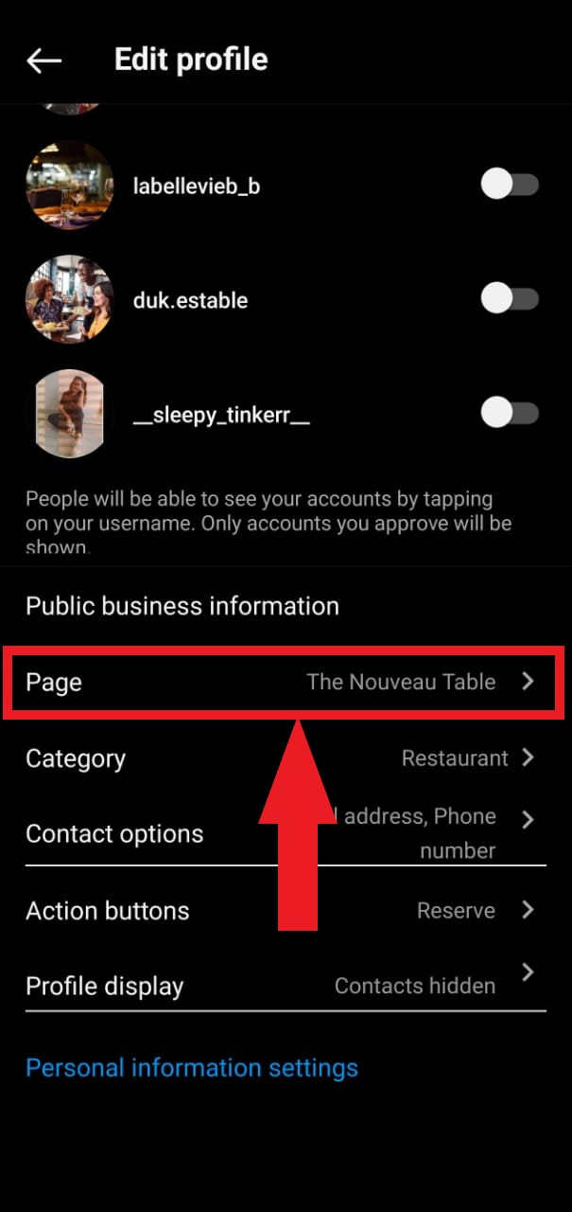

**Step 3**: Click 'Disconnect Page’ to continue.

