**How to Connect Instagram and Facebook accounts**

**Connect Accounts using Facebook Website:**

**Step 1**: Click on the “Settings” on the left side of the profile page.

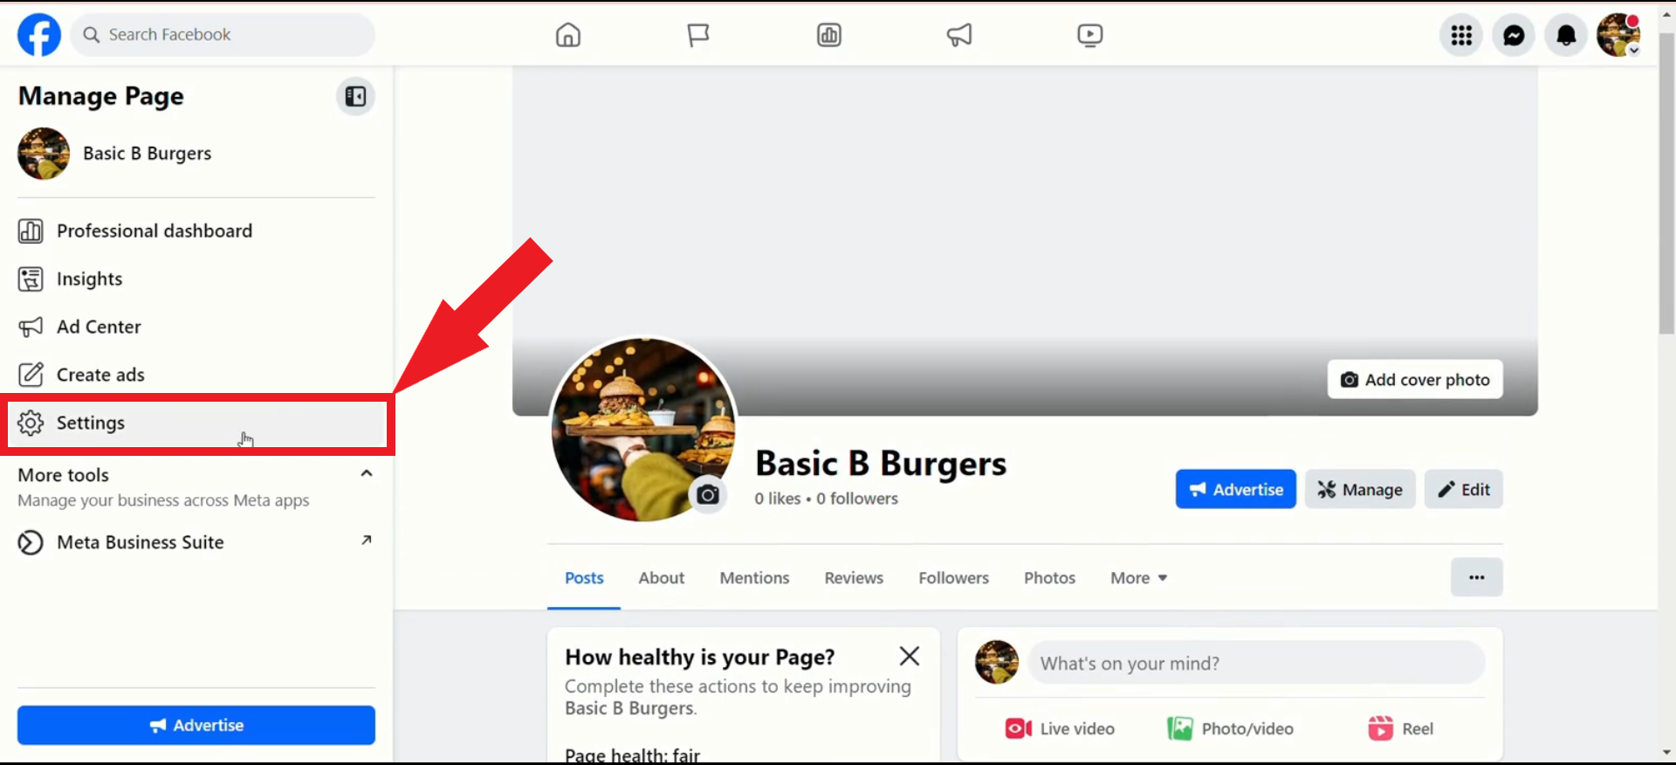

**Step 2**: Click 'Linked Accounts' on the left side.

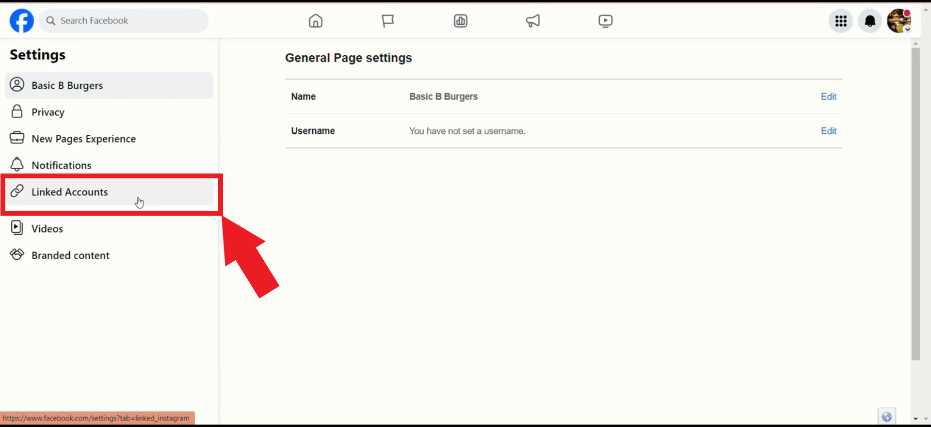

**Step 3**: Click on 'Connect account' as shown.

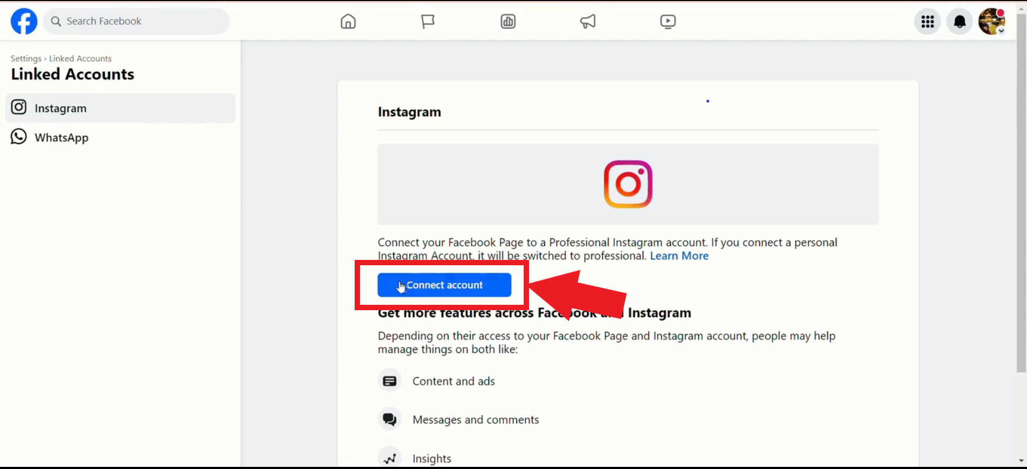

**Step 4**: Choose 'Connect’ to continue.

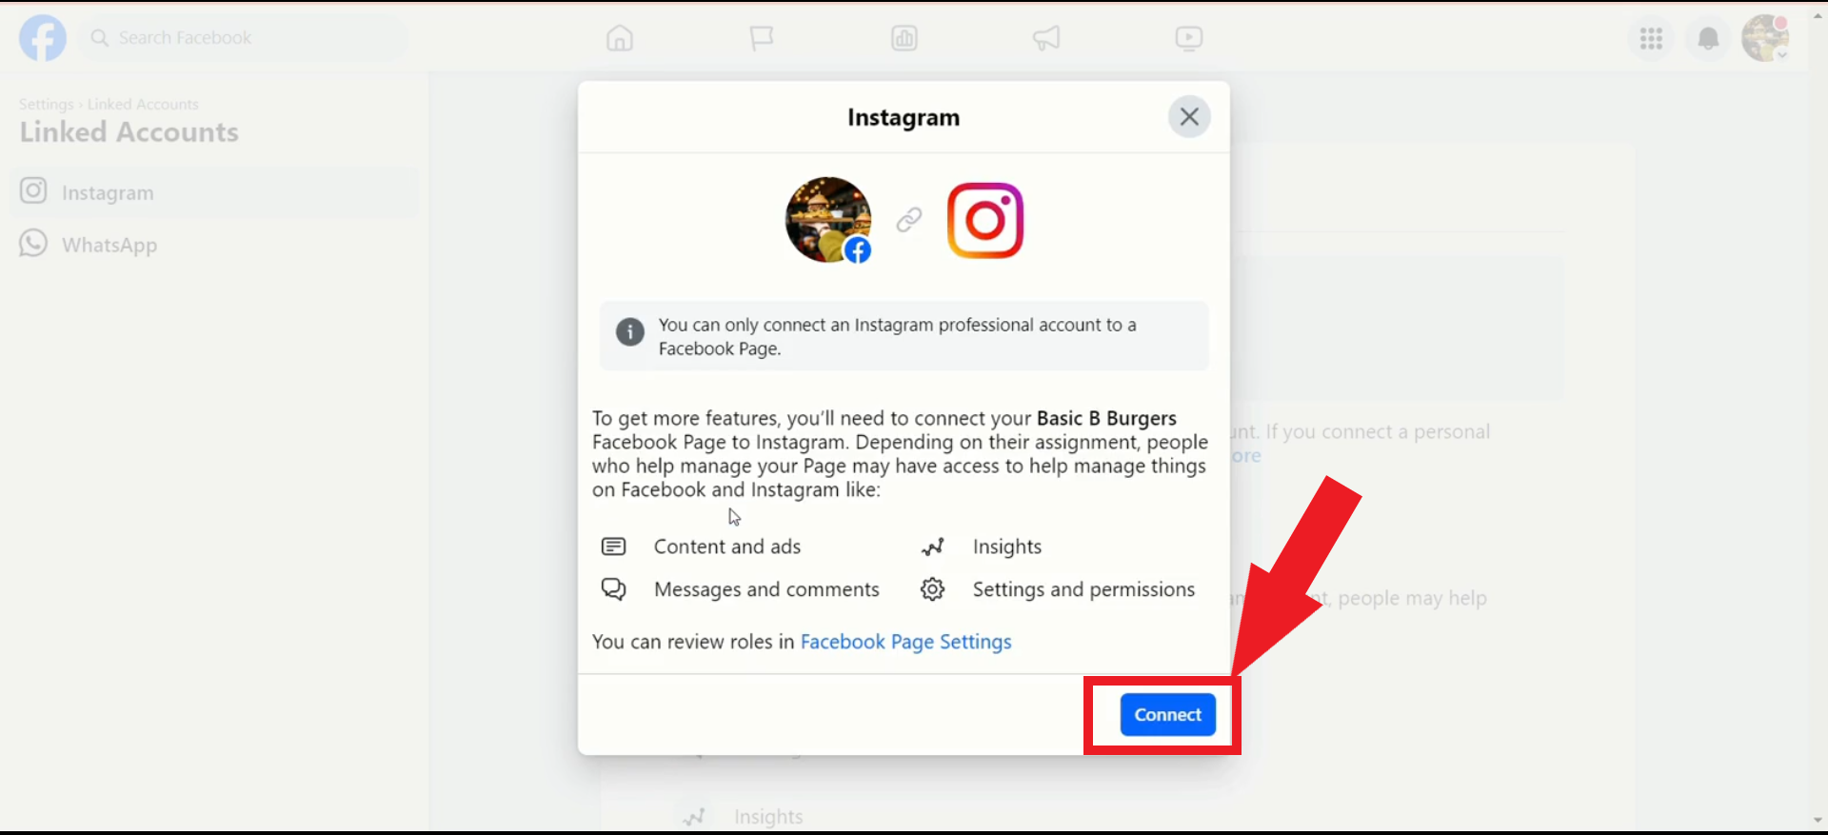

**Step 5**: Select 'Confirm' to continue.

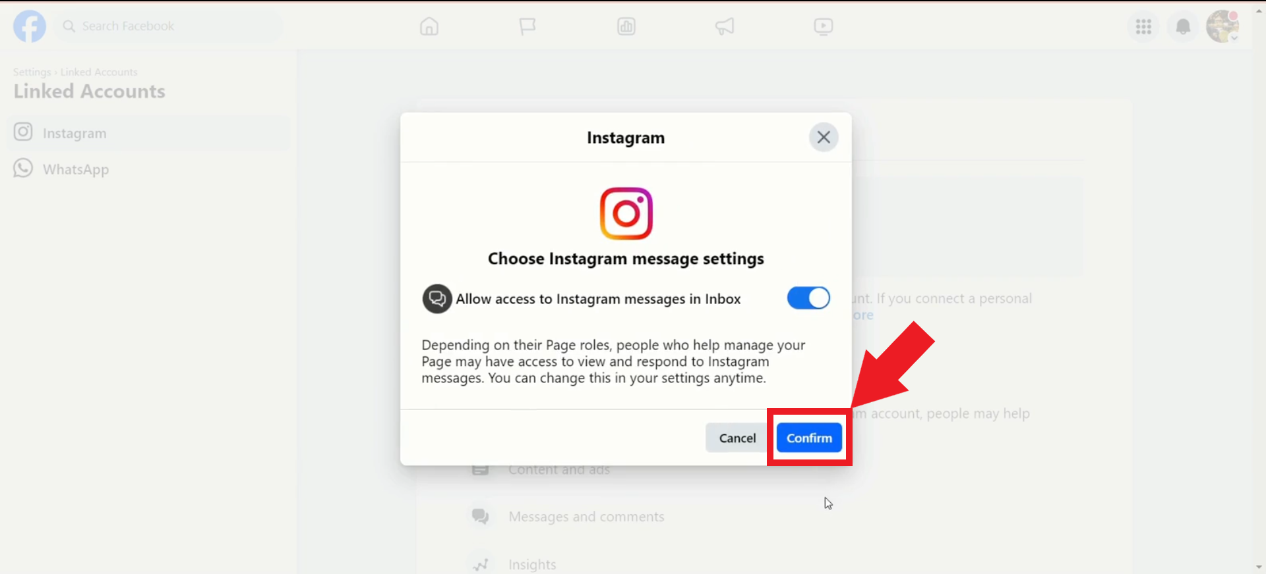

**Step 6**: Log in using your Instagram profile credentials.

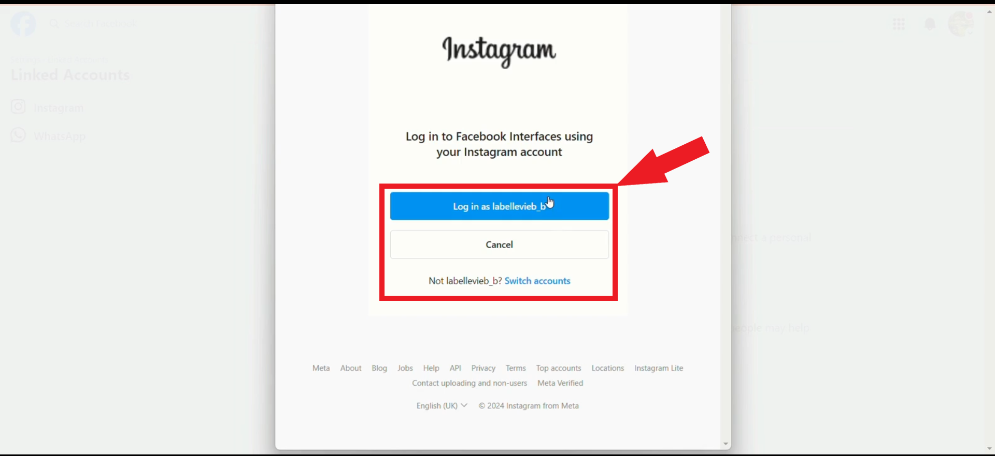

**Step 7**: You will see your Instagram page connected as shown below.

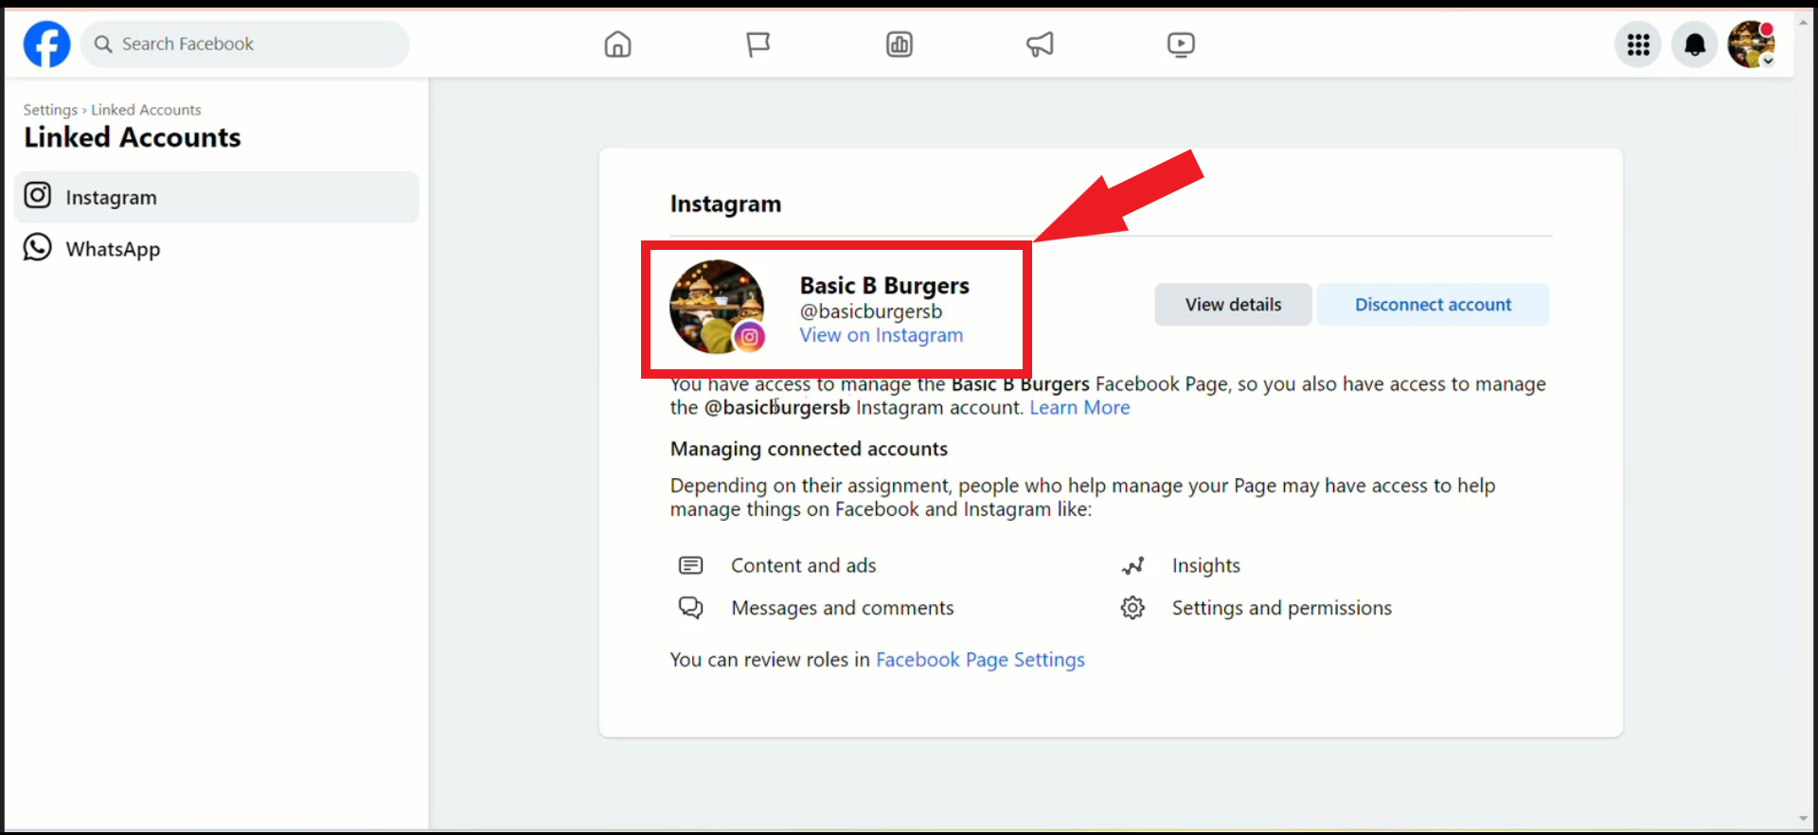

**Connect Accounts using Instagram App:**

**Step 1**: Select the “Edit Profile” as shown below.

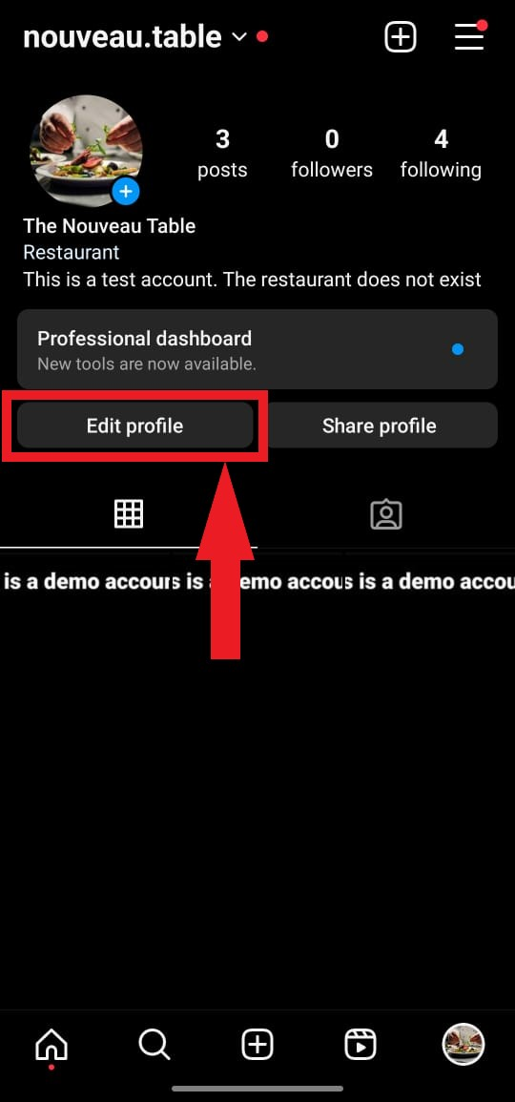

**Step 2**: Select “Page” as shown below to connect the Facebook profile.

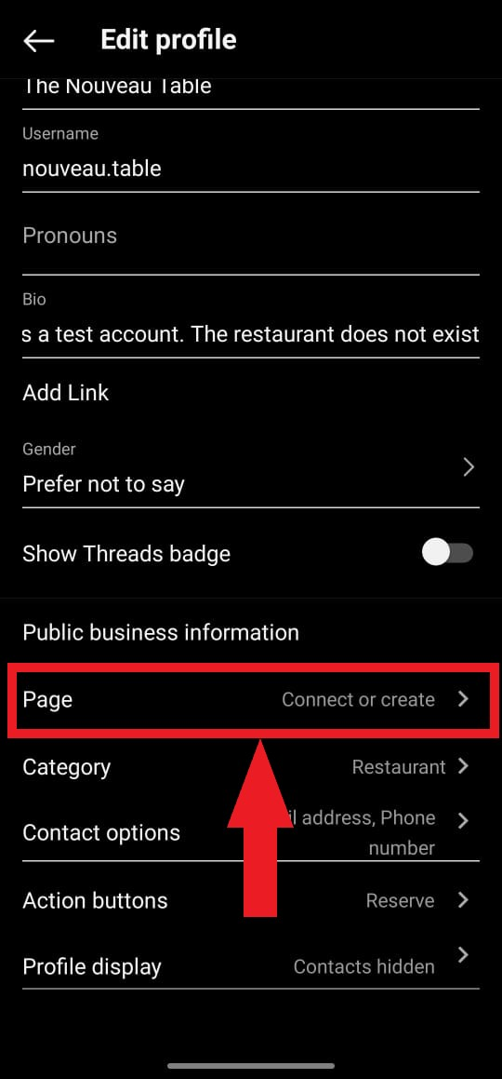

**Step 3**: Click 'Continue'.

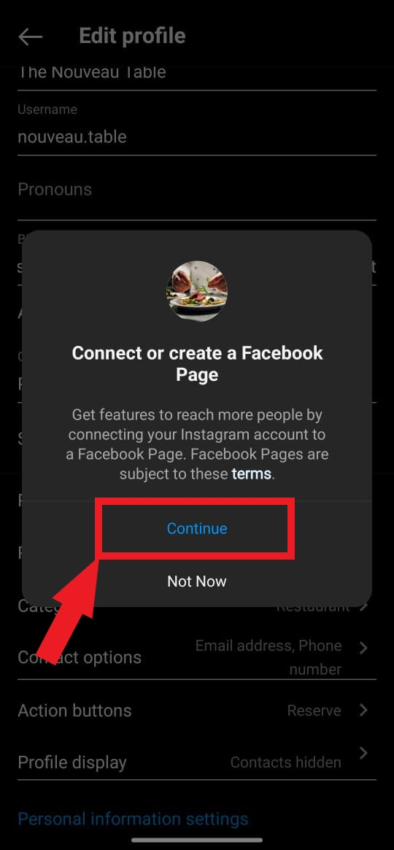

**Step 4**: Click ‘Log in to Facebook’ as shown below.

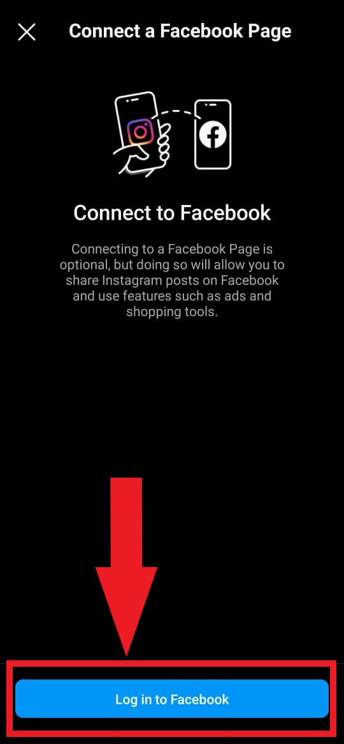

**Step 5**: Enter your Facebook Profile credentials to continue.

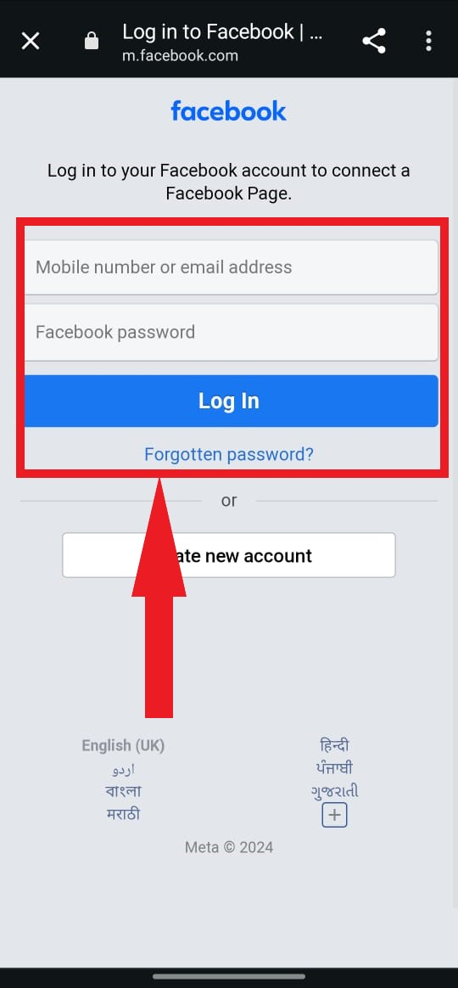

**Step 6**: Select the Facebook page that you want to connect.

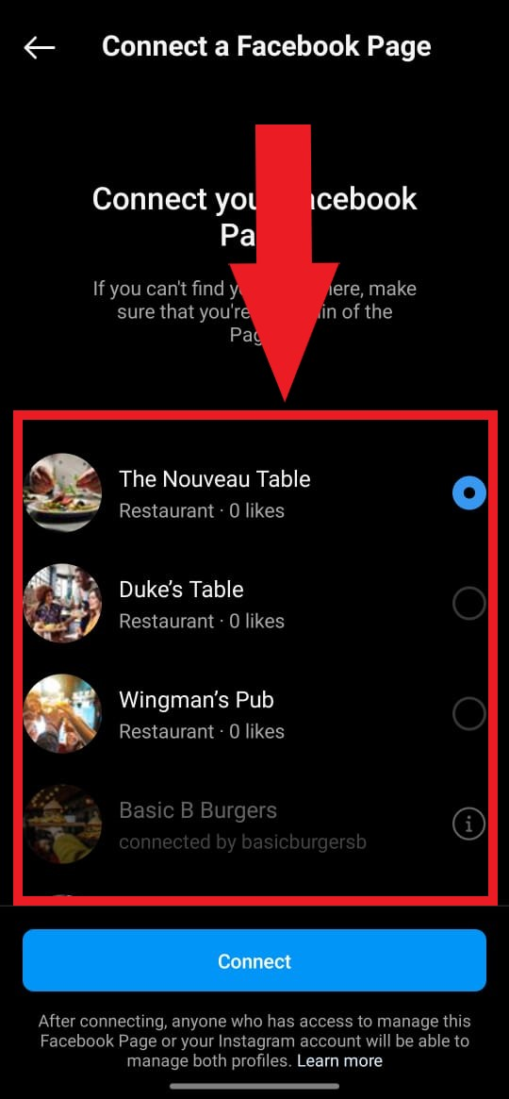

**Step 7**: Once successful, you will be able to see your Facebook page connected as shown below.

