How to add the ‘Reserve’ Button
to Facebook

Prerequisite:
The Facebook page must be linked to the Instagram page.

Step 1: Once both the Facebook and Instagram accounts are connected. Click on the three dots. Then, click 'Add Action Button'.

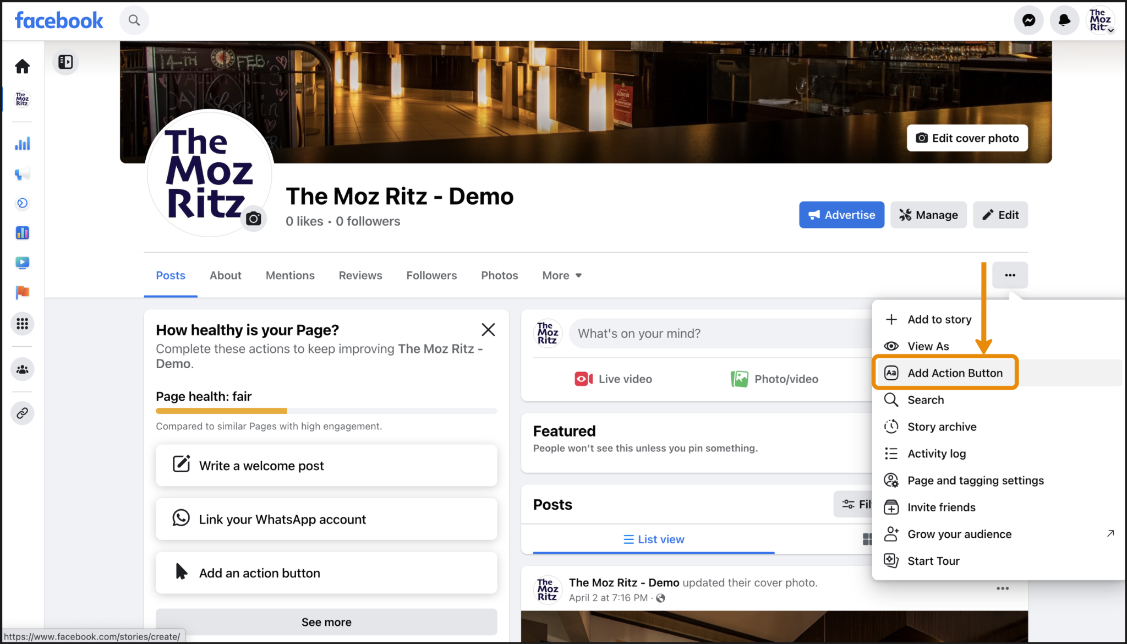

Step 2: Click 'Try It' on the popup window that opens.

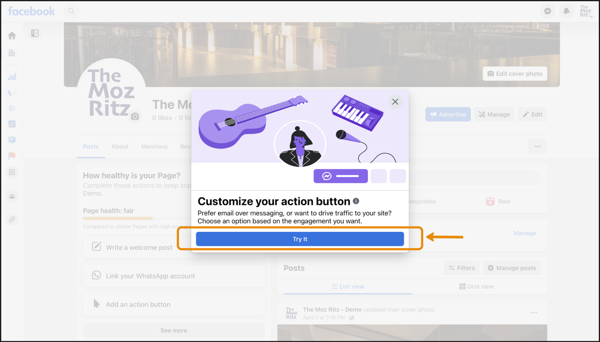

Step 3: Choose 'Reserve' from the list of action buttons.

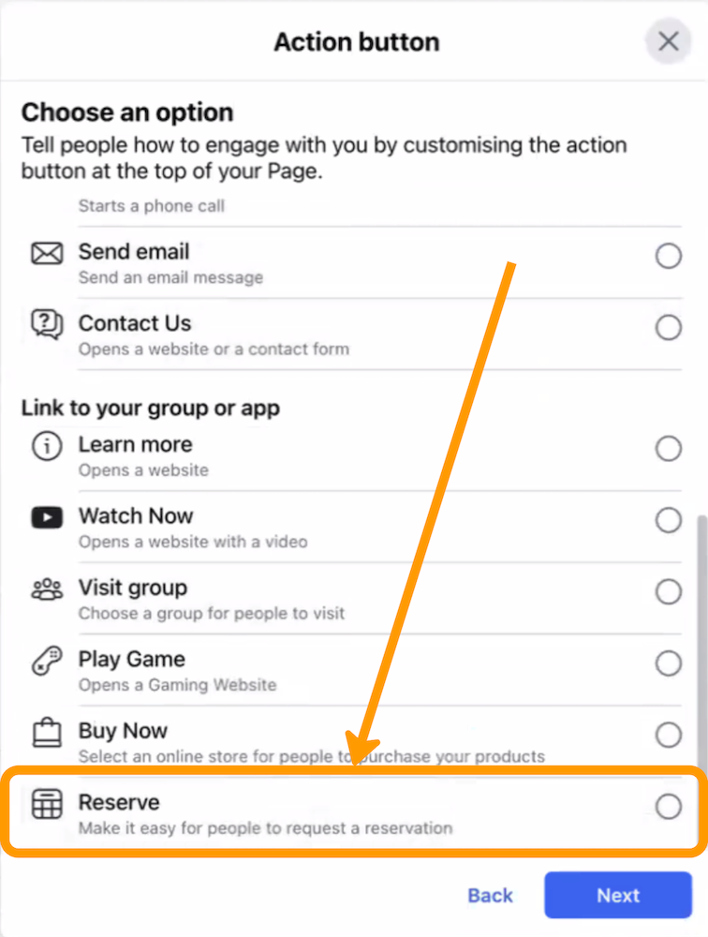

Step 4: Select 'Mozrest'.

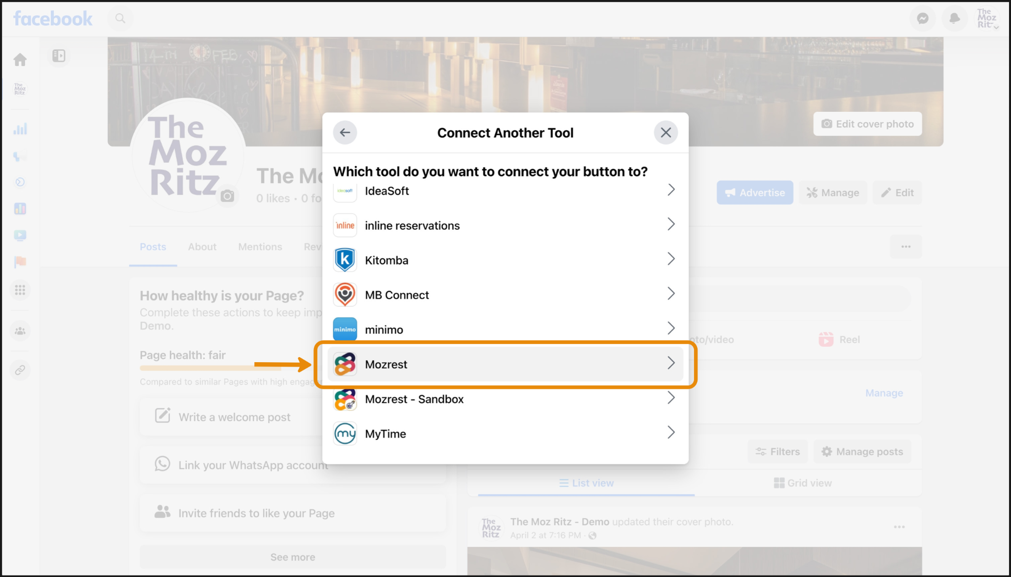

Step 5: Click 'Continue' to grant necessary permissions to Mozrest.

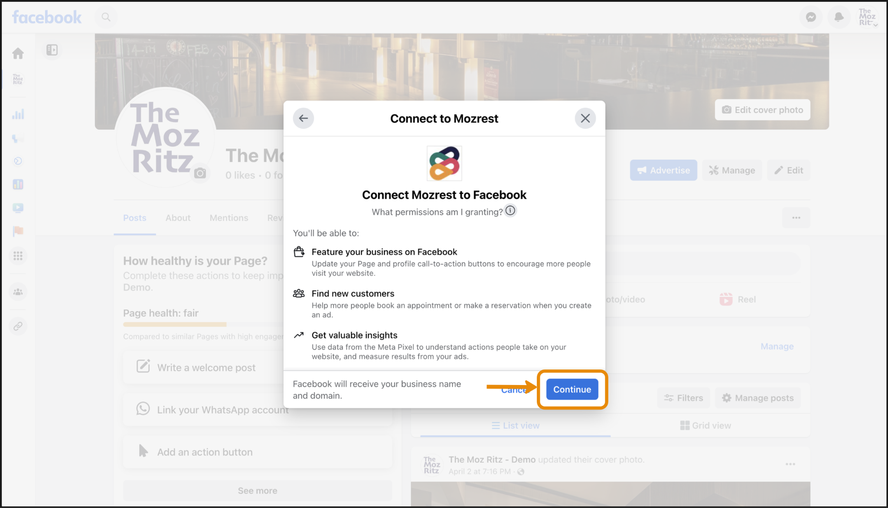

Step 6: Select your Reservation Management System to initiate the single sign-on process.

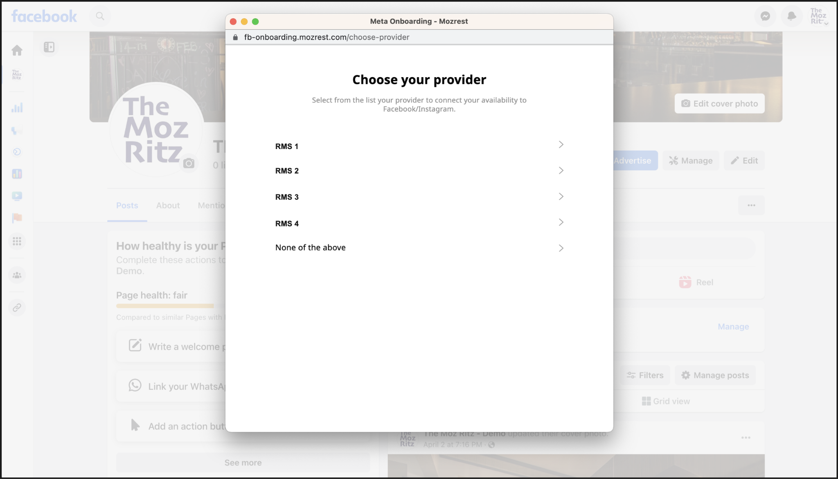

Step 7: Log in using your Reservation Management System login details to validate the connection to Facebook.

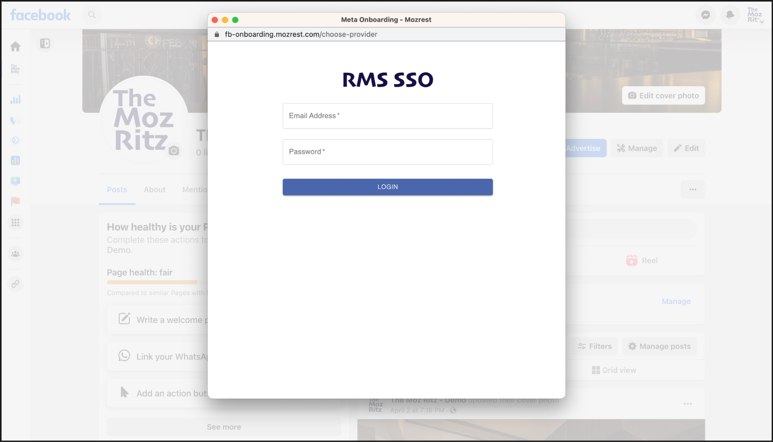

Step 8: Confirm the settings. Check steps 9.1-4* at the end of this section to change the account.

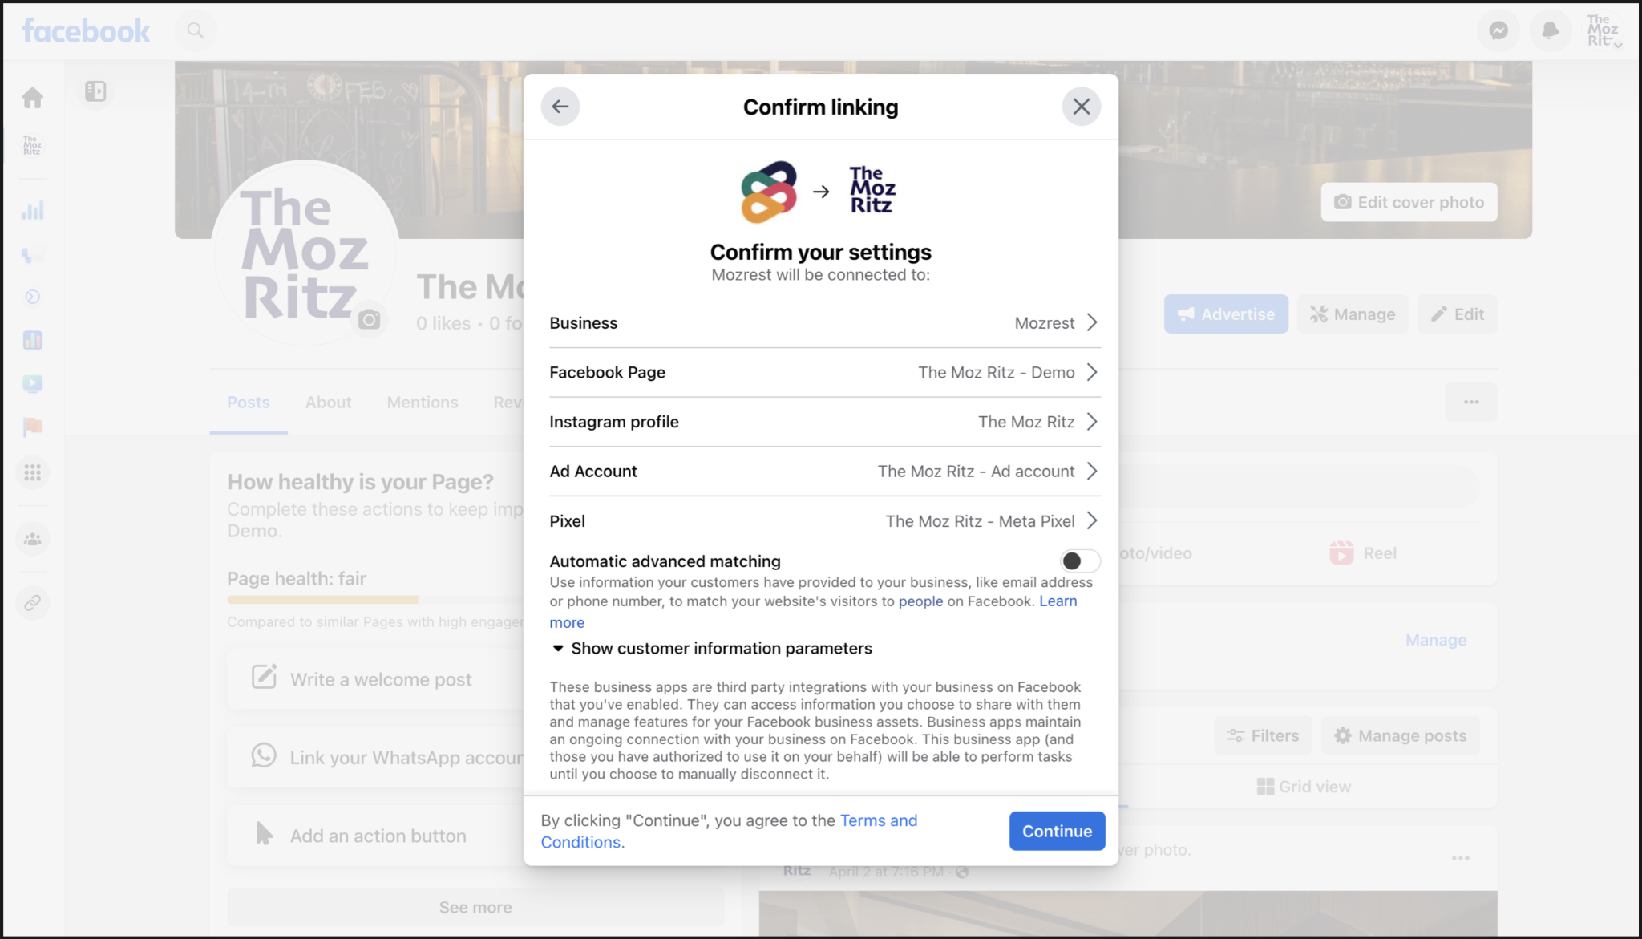

Step 9: Click 'Continue' to complete the integration.

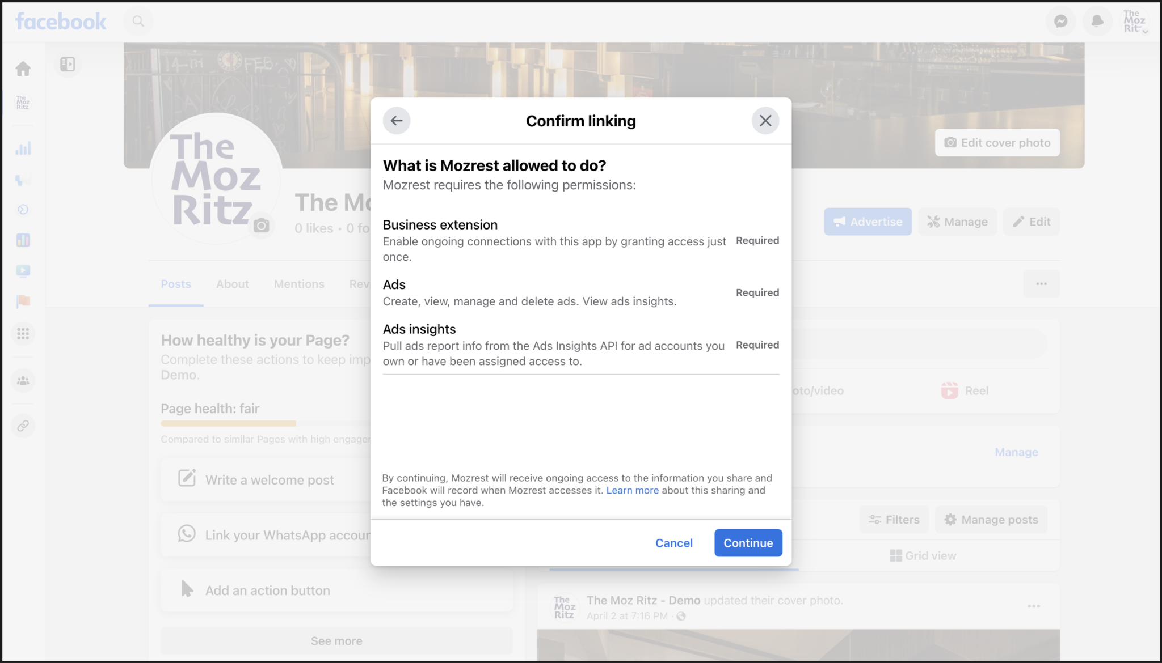

Step 10: Click 'Done'.

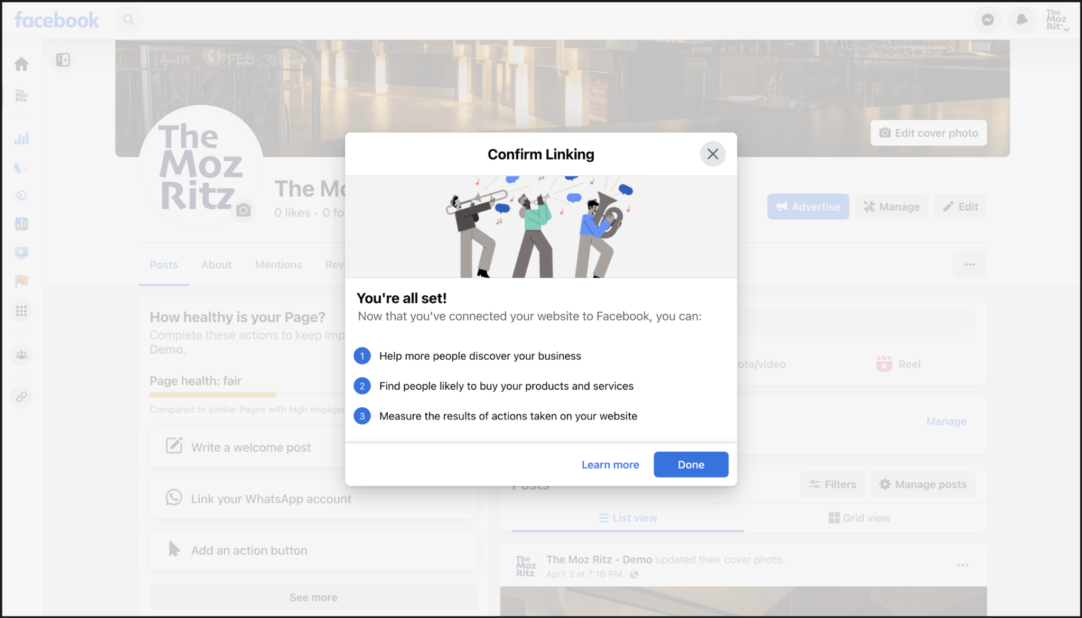

Step 11: Once successful, you will be able to see the 'Reserve' button on your Facebook page. When you select “View As” under the same three dots.

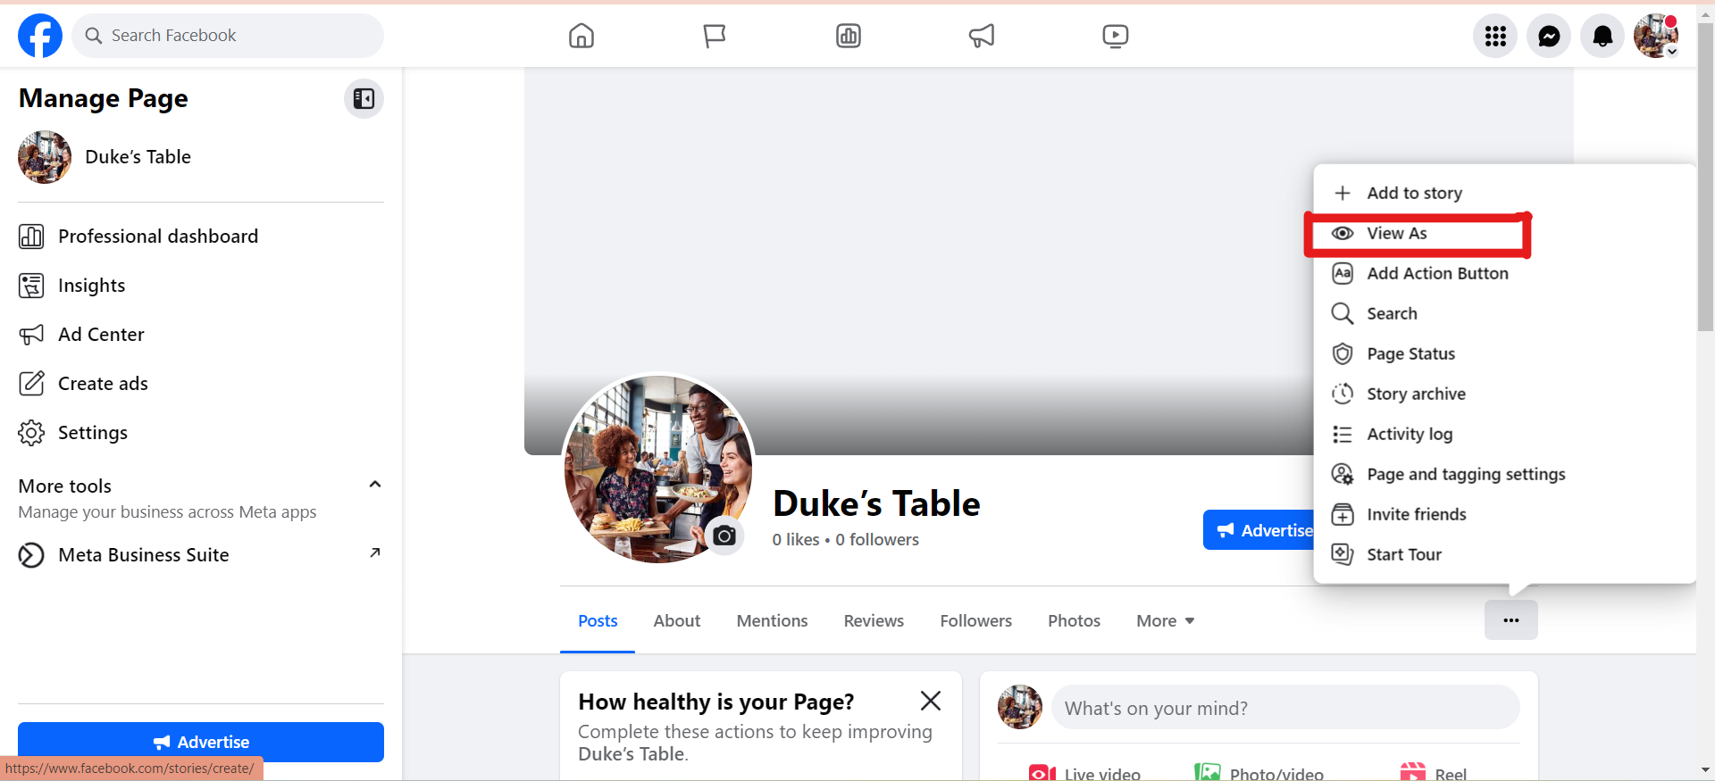
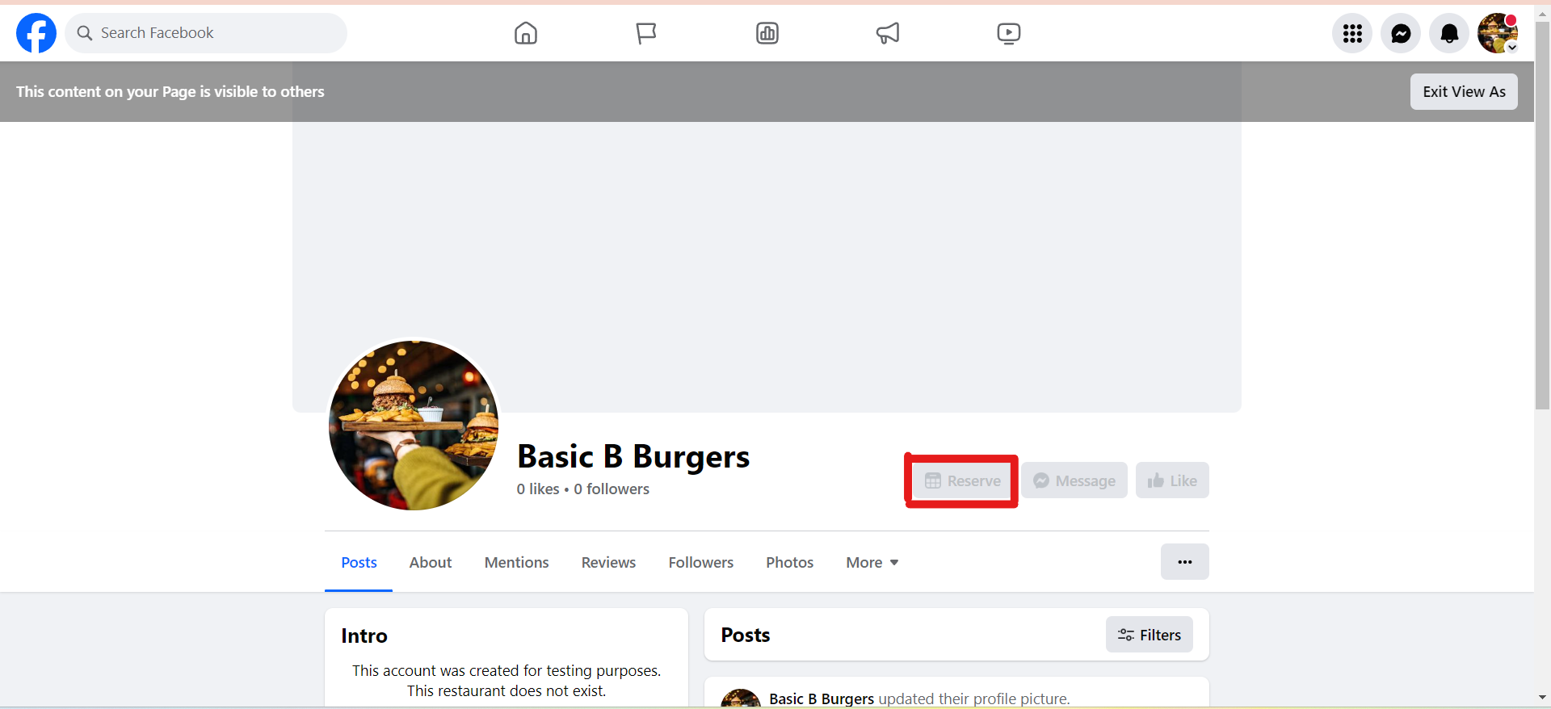

*Step 9.1: Select the preferred Facebook page (if you manage multiple pages).

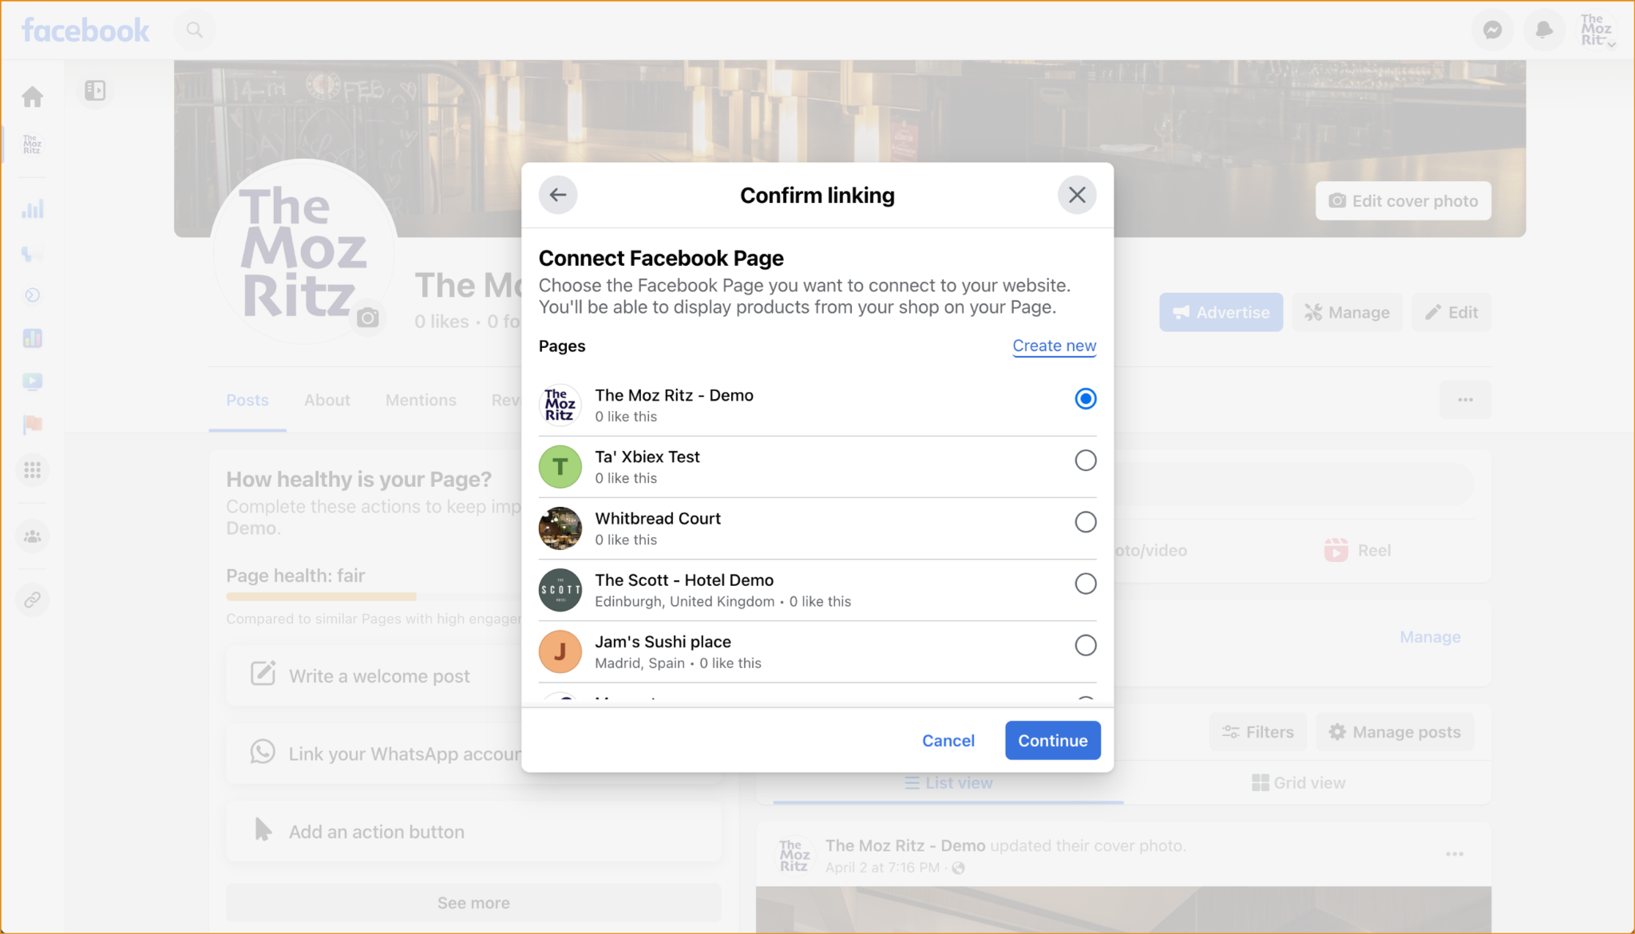

*Step 9.2: Select the preferred Instagram page to install the 'Reserve' button there too.

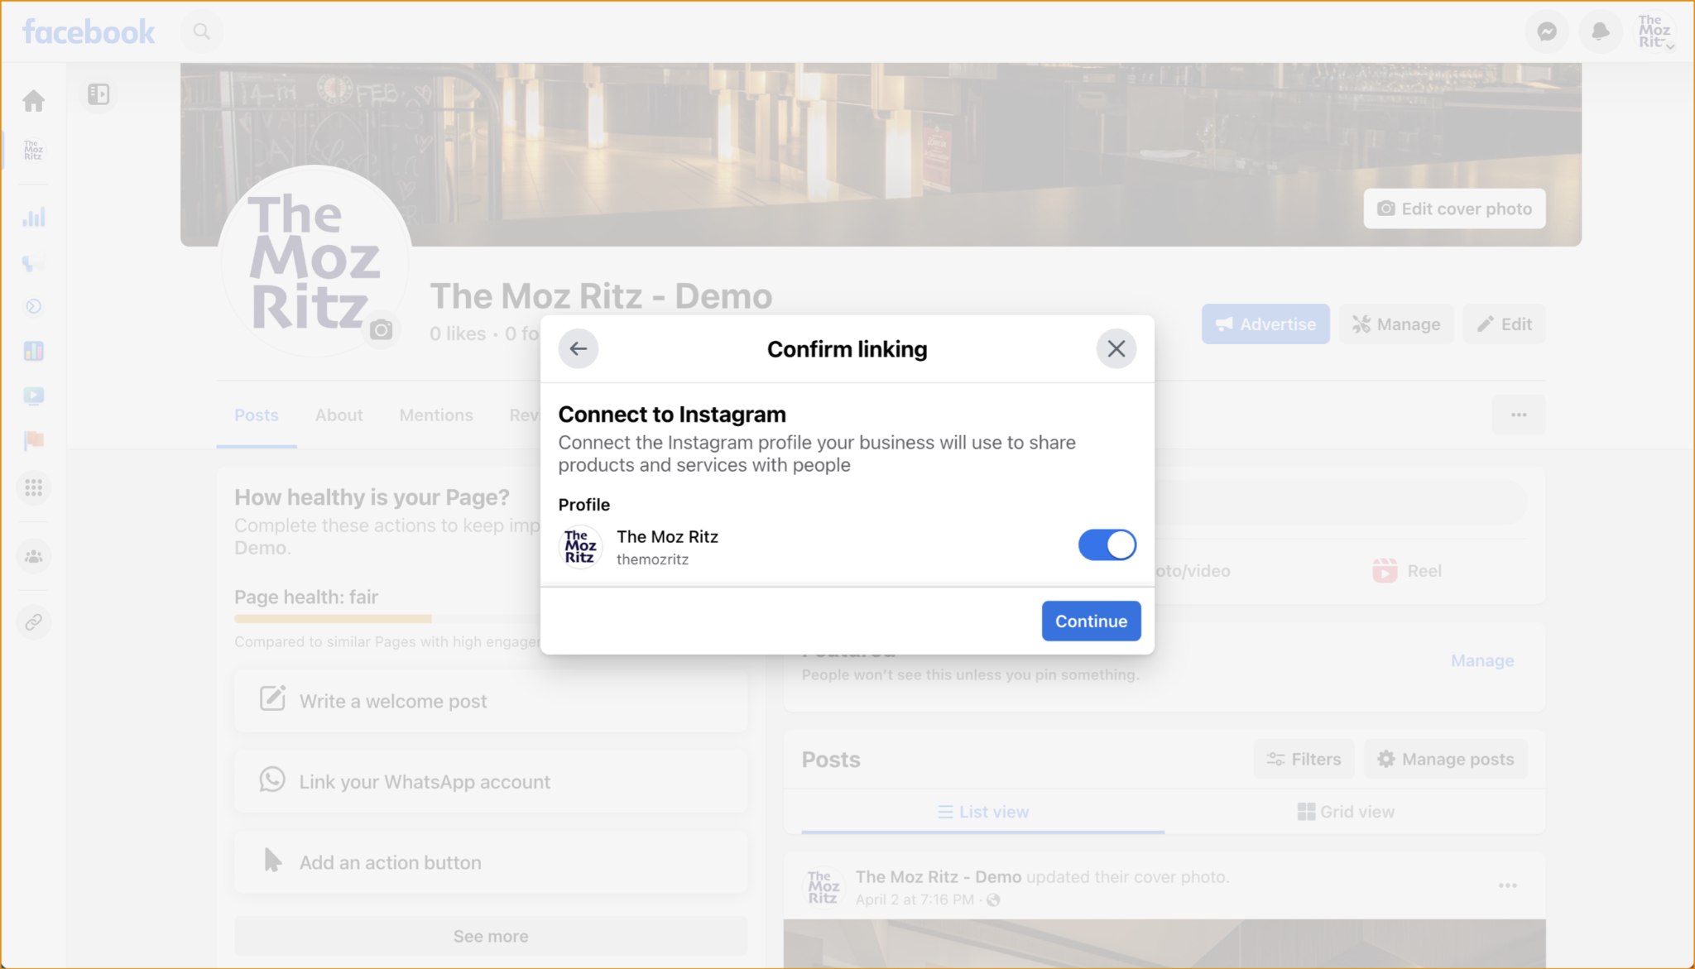

*Step 9.3: Select the preferred advertisement account.

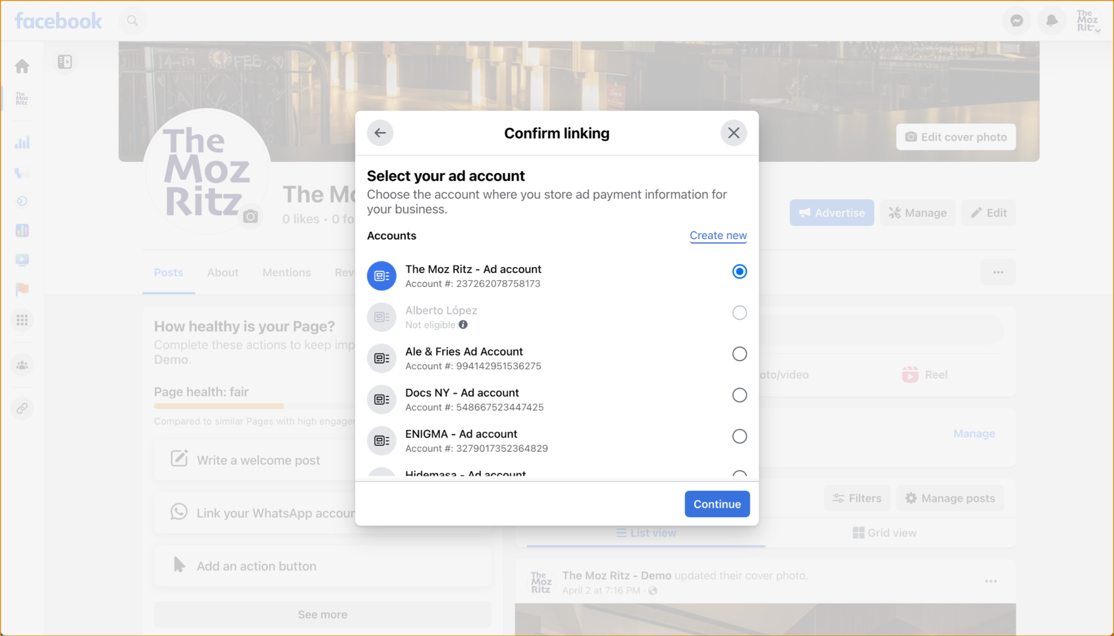

*Step 9.4: Select the preferred Meta pixel to use.

